window

tracetcp 10.240.192.150:3306

tracert 10.240.192.150

centos

sudo traceroute -T -p 8463 171.244.149.19 (centos 7)

sudo traceroute -T -p 21 10.60.156.167

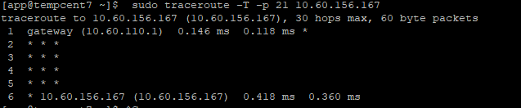

* Có kết nối,

Nếu chưa có Kn: check iptable

tracetcp.exe 10.255.65.75 22 (windows) hoặc tracetcp.exe 10.255.65.75:22